Project Design Phase-I
Solution Architecture

Date | 27 October 2026
Team ID | Individual
Project Name | Global Olympic Sports Performance Analysis
Maximum Marks | 4 Marks

Solution Architecture:
Solution architecture is a complex process – with many sub-processes – that bridges the gap between business problems and technology solutions. Its goals are to:
- Find the best tech solution to solve existing business problems.
- Describe the structure, characteristics, behavior, and other aspects of the software to project stakeholders.
- Define features, development phases, and solution requirements.
- Provide specifications according to which the solution is defined, managed, and delivered.

Sample Solution Architecture Diagram:
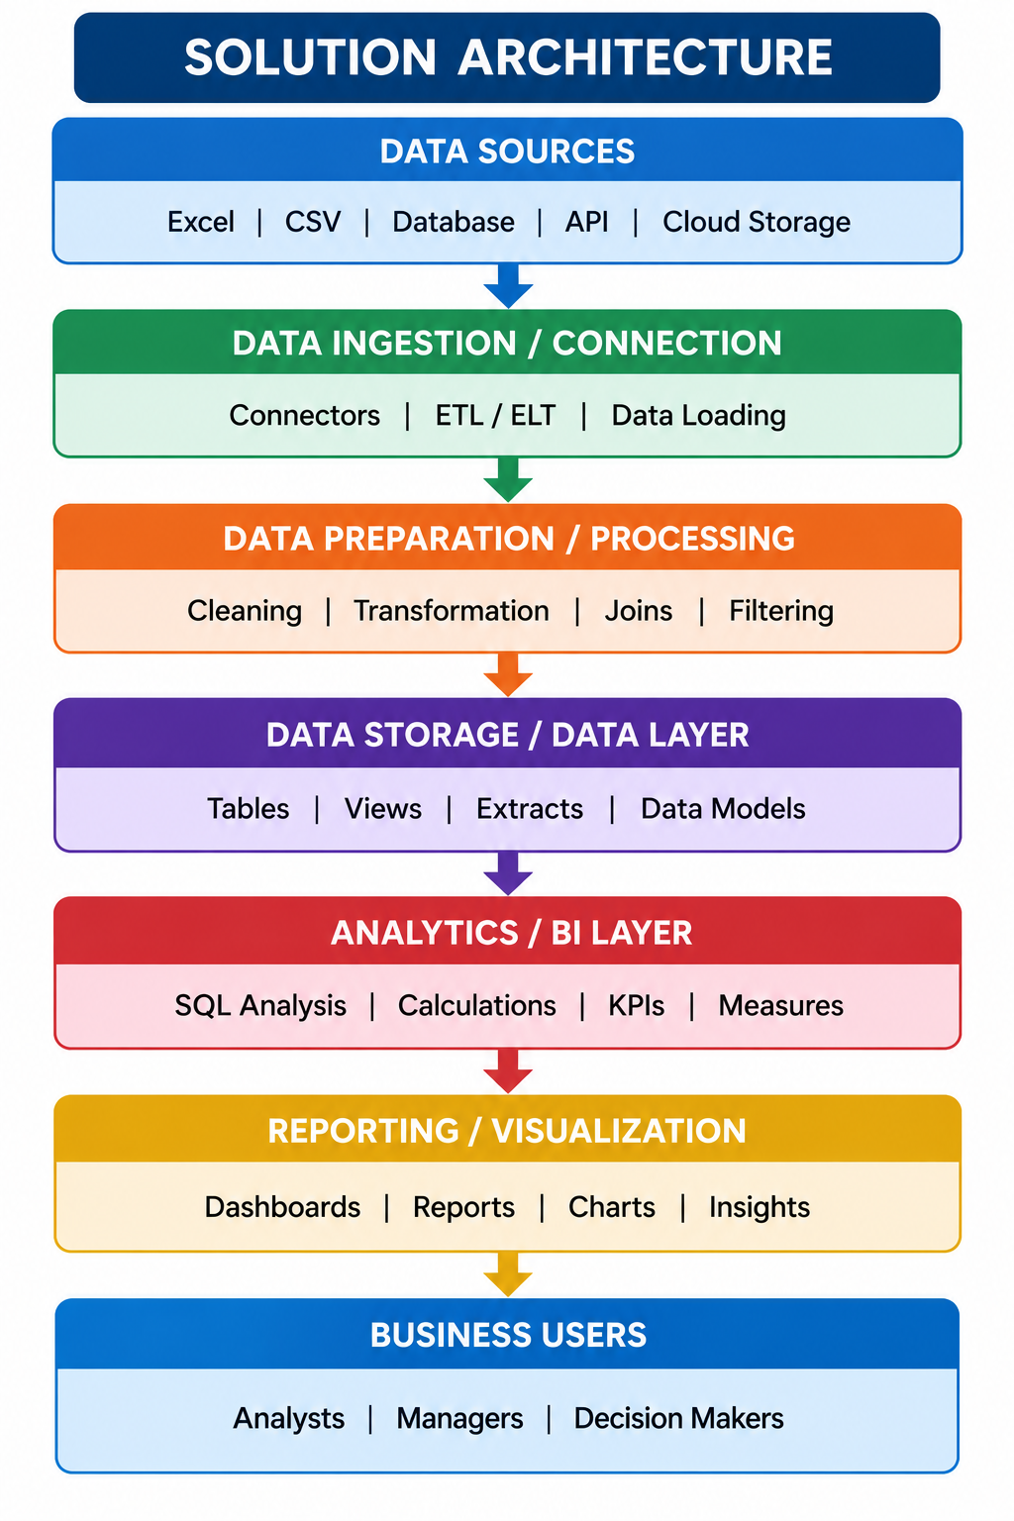

Component Description Table
Component Name | Description / Role in Architecture | Technology Used

Architecture Summary
Source layer: four CSV files. Data inspection layer: verify schema, types, missing values, duplicates, row grain, and metric definitions. Visualization layer: Tableau Public worksheets and calculations. Presentation layer: three dashboards and one story. Publication layer: Tableau Public URL (to be added after actual publication).
Component Description Table
1. CSV inputs — source records and summary measures. 2. Tableau data connections — connect each relevant CSV. 3. Worksheets — create nine individual views. 4. Dashboards — group the views into three stakeholder narratives. 5. Story — sequence the dashboards. 6. Validation — compare displayed values with source records and document limitations. 7. Publication — publish only after QA; public URL remains pending.
Planned 9 Tableau Worksheets
The following worksheet plan aligns with the three supplied stakeholder scenarios. These are planned views; final screenshots and exact results must be inserted after each worksheet is built and validated in Tableau Public.
Sheet | Chart | Chart type | Dataset / key fields | Scenario
Sheet 01 | Global Medal Performance by Country | Horizontal bar | alltime_country_rankings.csv: country; total_medals | Priya
Sheet 02 | Gold, Silver and Bronze Medals by Country | Stacked horizontal bar | alltime_country_rankings.csv: country; total_gold; total_silver; total_bronze | Priya
Sheet 03 | Summer vs Winter Olympic Medal Comparison | Side-by-side bars | alltime_country_rankings.csv: country; summer_medals; winter_medals | Priya
Sheet 04 | Total Medals Awarded Over the Years | Line | games_summary.csv: year; total_medals_awarded; season | William Robert
Sheet 05 | Athlete Participation Trends Across Olympic Games | Line | games_summary.csv: year; total_athletes; season | William Robert
Sheet 06 | Average Medals per Athlete by Sport Category | Horizontal bar | athletes.csv: sport_category; AVG(total_medals) | Priya
Sheet 07 | Average Medal Efficiency by Region | Bar | medal_results.csv: region; AVG(medal_efficiency_pct) | Carlos
Sheet 08 | Average Medal Performance by Sports Investment Tier | Bar | medal_results.csv: sports_investment; AVG(total_medals); region (optional color) | Carlos
Sheet 09 | Host-Nation Medal Performance Across Games | Bar | medal_results.csv: year; host_country; country; total_medals; host_nation | William Robert
Planned 3 Dashboards
Dashboard arrangement is planned as follows; publish links and screenshots remain to be added after the workbook is completed.
Dashboard | Worksheets | Purpose
Dashboard 1 — Global Olympic Performance | Sheets 1, 2, 3, 6 | Country medal rankings, medal-type composition, Summer/Winter comparison, and sport-category average medal counts.
Dashboard 2 — Investment and Regional Efficiency | Sheets 7, 8 | Regional average recorded efficiency and medal outcomes by investment tier; no monetary ROI claim.
Dashboard 3 — Olympic Trends and Host Nations | Sheets 4, 5, 9 | Recorded medal trends, athlete participation, and host-nation performance.

